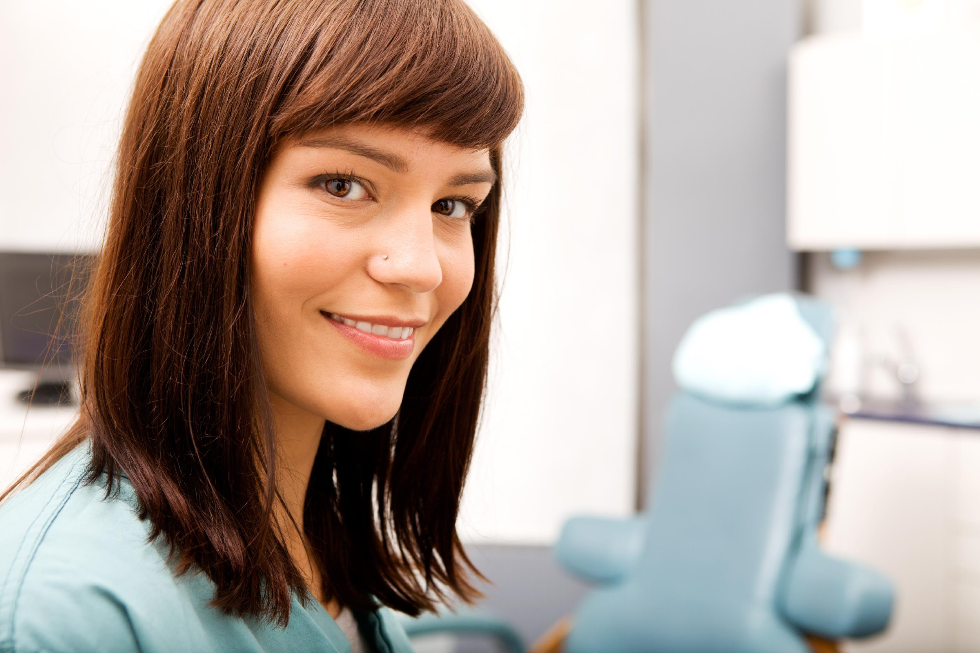
Ivana Jobb, RDA
3028 5th Ave, San Diego, CA 92103
------------------------------------------------------------------------------
Phone: (619) 295-1002
Email: info@directdentalstaffing.com

PROFESSIONAL PROFILE:
Highly motivated Registered Dental Assistant (license #12345) with over seven years of experience. Delivering excellent patient care and a superb overall experience is my strength and core focus.

Skills: ▪ 4 and 6 handed dentistry ▪ fabricate gorgeous temporaries ▪ Radiographs (FMX, PAS, BWS, Panoramic, Cephalometric) ▪ ZOOM Whitening ▪ Dentrix & Eaglesoft ▪Assisting IV sedation and General Anesthesia ▪ Rubber Dam Placement ▪ CEREC ▪ Invisalign ▪ Key front office skills

PROFESSIONAL EXPERIENCE:

Dr. One, San Diego, CA (March 2015 - present)

Lead Registered Dental Assistant
Assisted Dr. One with all procedures including endo, Invisalign, crowns, bridges and ZOOM whitening. Educated and trained staff on new products and procedures. Responsible for ordering all supplies and the scheduling of back office assistants.

Dr. Two, San Diego, CA (May 2012 – March 2015)

Registered Dental Assistant
Worked closely with Dr. Two and my team to ensure patient care was second to none. Procedures included dental implant placement and restoration, crowns, bridges and Invisalign. Was also cross trained to assist with scheduling implant surgeries. Worked with an Anesthesiologist.

Dr. Three, San Diego, CA (January 2010 - May 2012)

Dental Assistant/Front office receptionist
Ran both front and back office operations. Assisted the doctor with radiographs, suction, and sterilization. Handled insurance claims, scheduling patients, checking in and checking out patients, and treatment planning.

EDUCATION:

- San Diego Mesa College, Dental Assisting Certificate June 2012
- Continuing education credits available upon request

References, certificates and transcripts available upon request

